TEMPLATE

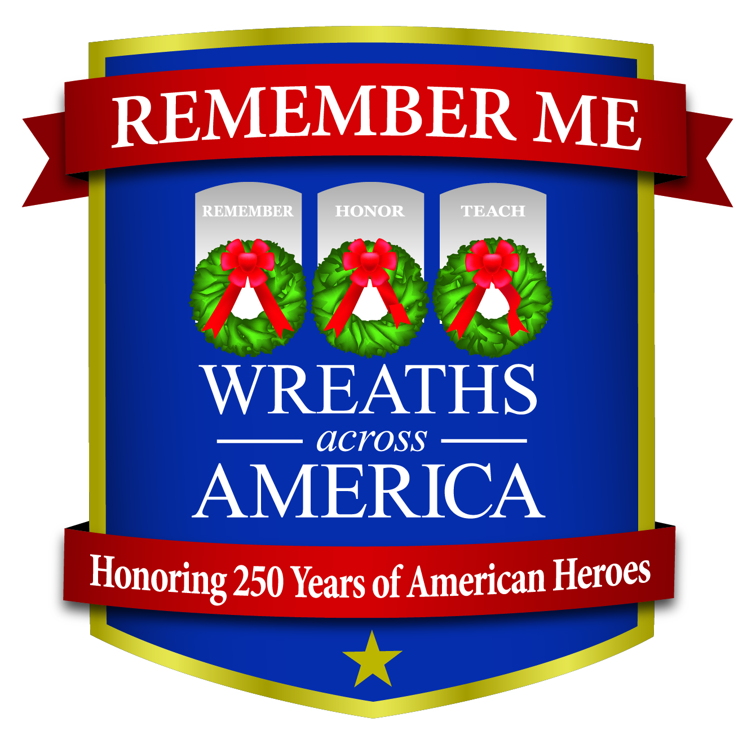

Nonprofit Wreaths Across America Announces New Theme for 2026: “Remember Me.”

COLUMBIA FALLS, Maine, and CITY, State Abr.— January XX, 2026 — Wreaths Across America (WAA), the national nonprofit with a yearlong mission dedicated to remembering the fallen, honoring those who serve and teaching children the value of freedom, announces “Remember Me” as its official theme for 2026.
The theme comes as the nation approaches the 250th anniversary of the United States, a milestone WAA says calls for renewed focus on the individual lives behind America’s military service. “While we often honor service members collectively, each one has a name, a family and a story,” says Karen Worcester, executive director, WAA. “Their sacrifices are deeply personal, and their stories shape the freedoms we enjoy today.”
The theme draws inspiration from an unexpected source: a line from the film “Home Alone 2.” The quote, “Maybe they don't forget about you, but they forget to remember you,” underscores the importance of actively remembering the individuals who served, especially those whose stories risk being lost to time.
Through ceremonies, education and community engagement in 2026, WAA will work to ensure that service members from the Revolutionary War to today are remembered and their stories continue to be told.
INSERT QUOTE: How will your location or group work to share this year’s theme and capture stories of those who served in your own community?
Click here to share names, photos and stories of forgotten servicemembers in your community. Follow along to learn and share the stories of those who served and time may have forgotten, but we will not, using the hashtag #RememberMe. Then, tune in to Wreaths Across America Radio, available on the iHeart Radio app, TuneIn, and the Audacy app, or listen at www.wreathsacrossamerica.org/radio. You can listen anytime on the Wreaths Radio SoundCloud page.

National Wreaths Across America Day will be held this year on Saturday, December 19, 2026. The free event is open to all. To support [Name of Location or Group] pleaes visit www.wreathsacrossamerica.org/YOURID.

# # #
About Wreaths Across America
Wreaths Across America is a 501(c)(3) nonprofit organization founded to continue and expand the annual wreath-laying ceremony at Arlington National Cemetery, which was begun by Maine businessman Morrill Worcester in 1992. The organization’s yearlong mission – Remember, Honor, Teach – is carried out in part by coordinating wreath-laying ceremonies in December in communities in all 50 states and beyond. Each $17 sponsorship supports far more than a single wreath. It fuels programs that honor veterans, teach future generations, and give back to communities nationwide.
Visit www.wreathsacrossamerica.org to learn more about how you can get involved in your local community.
Press contacts:
LOC POC
Phone #
Email

Rachael Wilson
(207) 230-4599
rwilson@wreathsacrossamerica.org
NOTE TO MEDIA:
Please visit the Media Resources Page to download background, photos, logos, or other items to help you file your story.

