FOR IMMEDIATE RELEASE

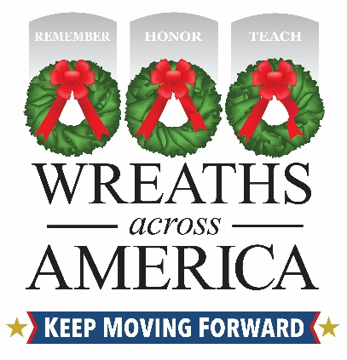

Wreaths Across America Day Clean-up Scheduled for (DATE) at (LOCATION)

Volunteers across the country placed 3.1 million veterans’ wreaths at nearly 5,600 participating locations on National Wreaths Across America Day.

(YOUR TOWN), (State Abbr.) — Jan. (date sent), 2025—National Wreaths Across America Day took place at nearly 5,600 participating locations across the country, including locally at [your cemetery]. Our heroes were remembered and honored as volunteers safely placing 3.1 million veterans’ wreaths on headstones nationwide, while saying each name out loud. As we honor our veterans, we also honor the host grounds for allowing the mission to be fulfilled with a follow-up effort of wreath retirement or clean up.

[Volunteers needed] Please join us for this year’s wreath retirement as volunteers are needed to help with this effort on [date, time] at [cemetery] located at [address].

Please also include other info such as:

- If the public needs to register, if so, provide a link
- Where to find available parking or transportation if provided
- What to wear/bring (weather related)

[Volunteers NOT needed] The local [group or volunteers] will be taking care of this year’s wreath retirement effort on [date, time] at [cemetery] located at [address].

[If you are doing something special with the wreaths] As we retire this year’s wreaths from service to our honored veterans, we want you to know that they will serve a secondary purpose. These wreaths will be ear-marked for:

- Recycling program
- Other

Wreaths Across America would like to thank the dedicated volunteers, local officials, professional truck drivers and participating veterans service organizations, for their support in 2025. Each person has played an important a part in the mission to Remember the fallen, Honor those that serve, and Teach the next generation the value of freedom.

For more information, visit www.wreathsacrossamerica.org/GroupID to help us get started on this year’s upcoming National Wreaths Across America Day, to be held on Saturday, Dec. 19, 2026.

# # #
About Wreaths Across America
Wreaths Across America is a 501(c)(3) nonprofit organization founded to continue and expand the annual wreath-laying ceremony at Arlington National Cemetery begun by Maine businessman Morrill Worcester in 1992. The organization’s mission – Remember, Honor, Teach – is carried out in part each year by coordinating wreath-laying ceremonies in December at Arlington, as well as at thousands of veterans’ cemeteries and other locations in all 50 states and beyond. For more information or to sponsor a wreath please visit www.wreathsacrossamerica.org.

Local contact:
Local Person
Email Address
Local contact number

National Contact
Rachael Wilson
rwilson@wreathsacrossamerica.org
(207) 230-4599

Please visit the Media Resources Page to download background, photos, logos, or other items to help you file your story.

