FOR IMMEDIATE RELEASE

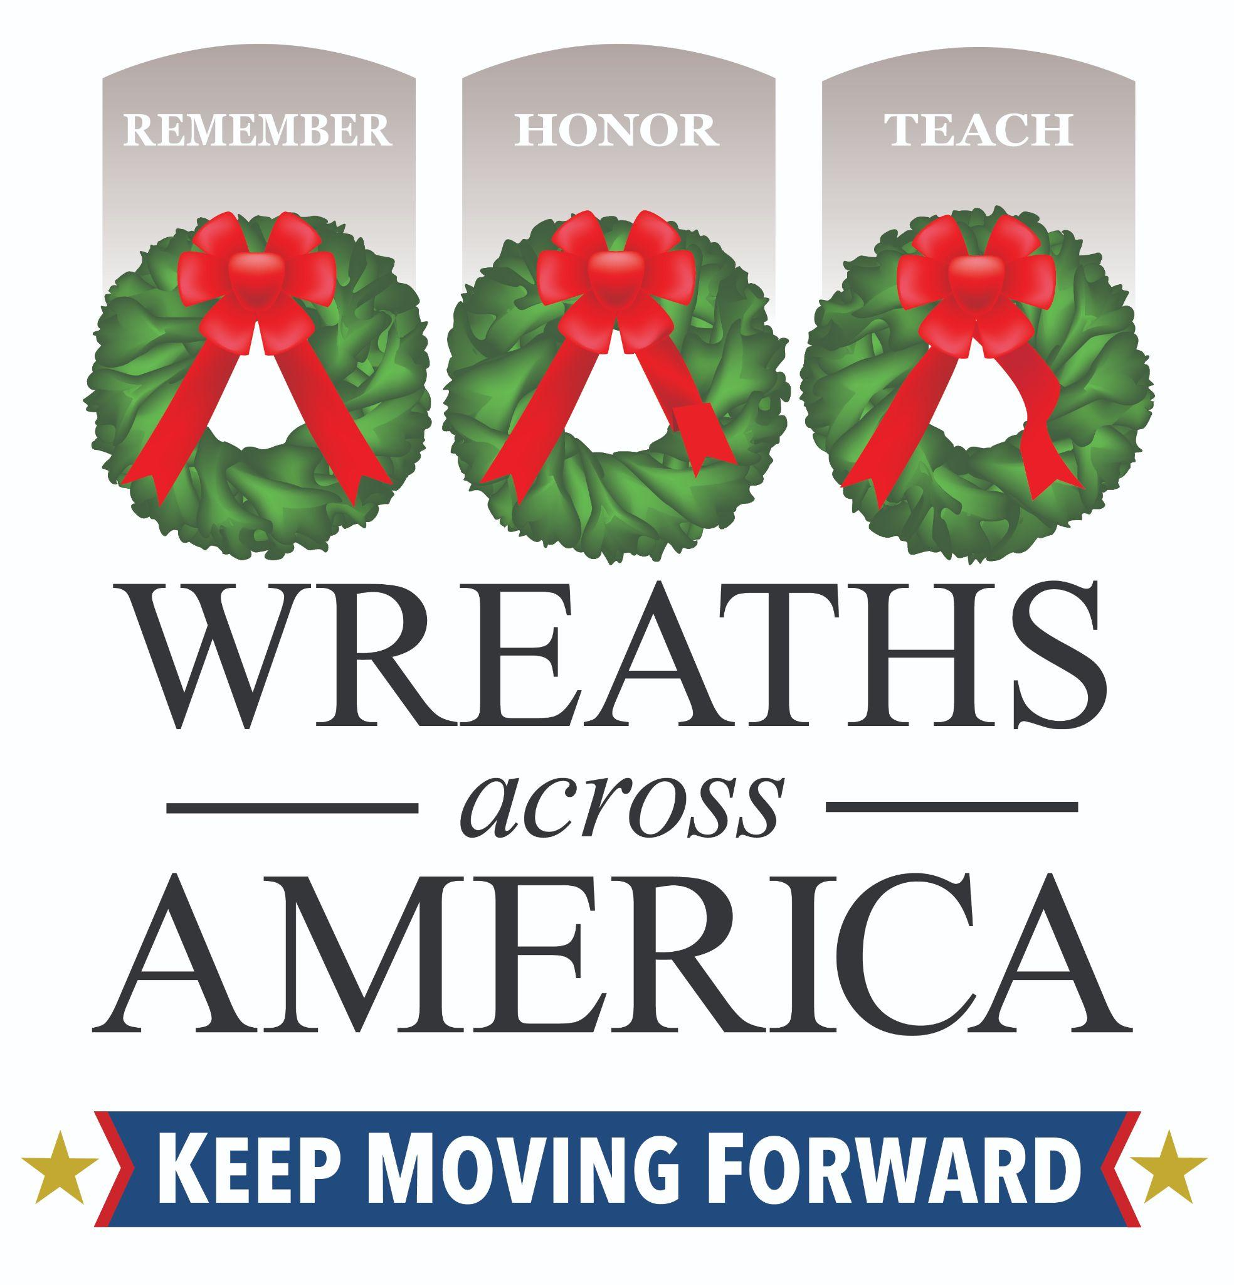
Nearly 5,600 Locations Nationwide Honor Veterans with Remembrance Wreaths on National Wreaths Across America Day 2025
Volunteers in CITY honor XXXX fallen service members at LOCATION on National Wreaths Across America.

COLUMBIA FALLS, Maine – Dec. 13, 2025 – Today, National Wreaths Across America Day took place at 5,598 participating locations nationwide. Millions of volunteers — a third of whom were children — remembered our nation’s heroes as they said their names out loud, with the placement of over 3.1 million sponsored veterans’ wreaths. At [LOCATION] in [CITY/TOWN], volunteers honored [XXXX] service members laid to rest there.

[Insert details you’d like to share about your event, and/or a quote about the impact of the mission in your community.]

For centuries, fresh evergreens have been used to symbolize honor and serve as a living tribute, renewed annually. Wreaths Across America believes the tradition represents a living memorial that honors veterans, active-duty military, and their families. When volunteers say the name of a veteran aloud while placing a wreath, it ensures they live on in our hearts and memories, remembered for years to come.

“The wreaths laid today serve as a powerful gesture that unites communities, families, and even generations. It serves as an opportunity to learn about the men and women who served and sacrificed to protect our freedom,” said Karen Worcester, executive director of Wreaths Across America. “I am in awe of what our volunteers accomplish to remember our nation’s service members each year. We extend our gratitude to all of our volunteers nationwide for their commitment to upholding our year-round mission to Remember, Honor, and Teach each and every day.”

Wreaths Across America would like to thank the communities, dedicated volunteers, and generous sponsors for supporting those who have protected our freedom and their families. Each person has played a part in the year-long mission to Remember the fallen, Honor those who serve, and Teach the next generation the value of freedom.

For more information about the year-long mission and ways to get involved in the local effort for 2026, please visit www.wreathacrossamerica.org/YOURID. It’s never too early to join the mission and support these local efforts.

National Wreaths Across America Day will be held next year on Saturday, December 19, 2026.

# # #

About Wreaths Across America
Wreaths Across America is a 501(c)(3) nonprofit organization founded to continue and expand the annual wreath-laying ceremony at Arlington National Cemetery begun by Maine businessman Morrill Worcester in 1992. The organization’s yearlong mission – Remember, Honor, Teach – is carried out in part each year by coordinating wreath-laying ceremonies in December at Arlington, as well as at thousands of veterans’ cemeteries and other locations in all 50 states and beyond.

Media Contacts:
Volunteer LC Name
Email
Phone

Rachael Wilson, PR Coordinator
Wreaths Across America
rwilson@wreathsacrossamerica.org
(207) 230-4599

Please visit our Media Resources Page to download background, photos, logos, or other items to help you file your story. Additional press photos and video can be made available upon request.

