FOR IMMEDIATE RELAEASE
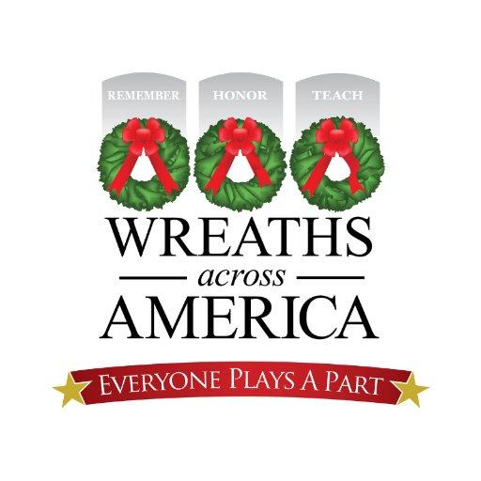
Saturday, December 19, 2020, is National Wreaths Across America Day
Local Volunteers who Coordinate the Program at [Participating Location] are Finalizing Modified Plans for the Wreath Laying Event to Take Place Safely as Scheduled

(YOUR TOWN, STATE) — (Date), 2020 — Locally, volunteers supporting Wreaths Across America at [Participating Location] have been working hard to ensure that the [number of graves] service members buried there will indeed be honored again this year with the placement of live, balsam veterans’ wreaths as part of National Wreaths Across America Day 2020.

This year, the ceremonies that are held across the country at more than 2,200 participating locations, may look a little different as the national nonprofit is making every effort to meet CDC recommended safety guidelines while also adhering to state, local, and cemetery safety measures that have been implemented due to COVID-19.

At [Participating Location] the following modifications have been made to maintain a safe and successful event.

INSERT APPROVED DETAILS FOR THE DAY – A LIST FORMAT INCLUDING WHO TO CONTACT WITH QUESTIONS IS IDEAL.

We encourage all those interested in participating in this year’s wreath placement to register to volunteer so that you can be kept up-to-date on details for the day as it gets closer. You can register to volunteer at www.wreathsacrossamerica.org/YOURID.

“It is important that during challenging times we all take a moment to remember those who have met and overcome challenges – like our nation’s military and their families – and show unity in our American spirit while we work together in an effort to march forward in the face of what seems to be insurmountable odds,” said Karen Worcester, executive director of Wreaths Across America. “We are so grateful to the good people of this great nation for participating in the mission to Remember, Honor and Teach.”

National Wreaths Across America Day is a free, non-political event, that is usually open to all people, but this year each individual location will be abiding by all local and state safety guidelines and rules set forth by the participating cemetery locations, at which Wreaths Across America is a guest.

To sponsor a wreath and stay informed about event details, we encourage you to visit www.WreathsAcrossAmerica.org/YOURID

Wreaths Across America is the non-profit organization best known for placing veterans’ wreaths on the headstones of our nation’s fallen at Arlington National Cemetery. However, the organization, in total, places more than 2.2 million sponsored wreaths at over 2200 participating locations nationwide and offers other programs throughout the calendar year, including The Mobile Education Exhibit , Wreaths Across America Radio, and the Wreaths Across America Virtual Concert now streaming on Showcase NOW).

# # #

About Wreaths Across America:
Wreaths Across America is a 501(c)(3) nonprofit organization founded to continue and expand the annual wreath-laying ceremony at Arlington National Cemetery begun by Maine businessman Morrill Worcester in 1992. The organization’s mission – Remember, Honor, Teach – is carried out in part each year by coordinating wreath-laying ceremonies in December at Arlington, as well as at thousands of veterans’ cemeteries and other locations in all 50 states and beyond.

This year’s Wreaths Across America Day is December 19th, 2020. For more information or to sponsor a wreath, please visit www.wreathsacrossamerica.org.

Press contacts:
Location Coordinator Name
Participating Location
Email address that you check often
(area code) phone number that is most reliable to reach you

Sean Sullivan
Wreaths Across America
ssullivan@wreathsacrossamerica.org
(207) 230-4599

