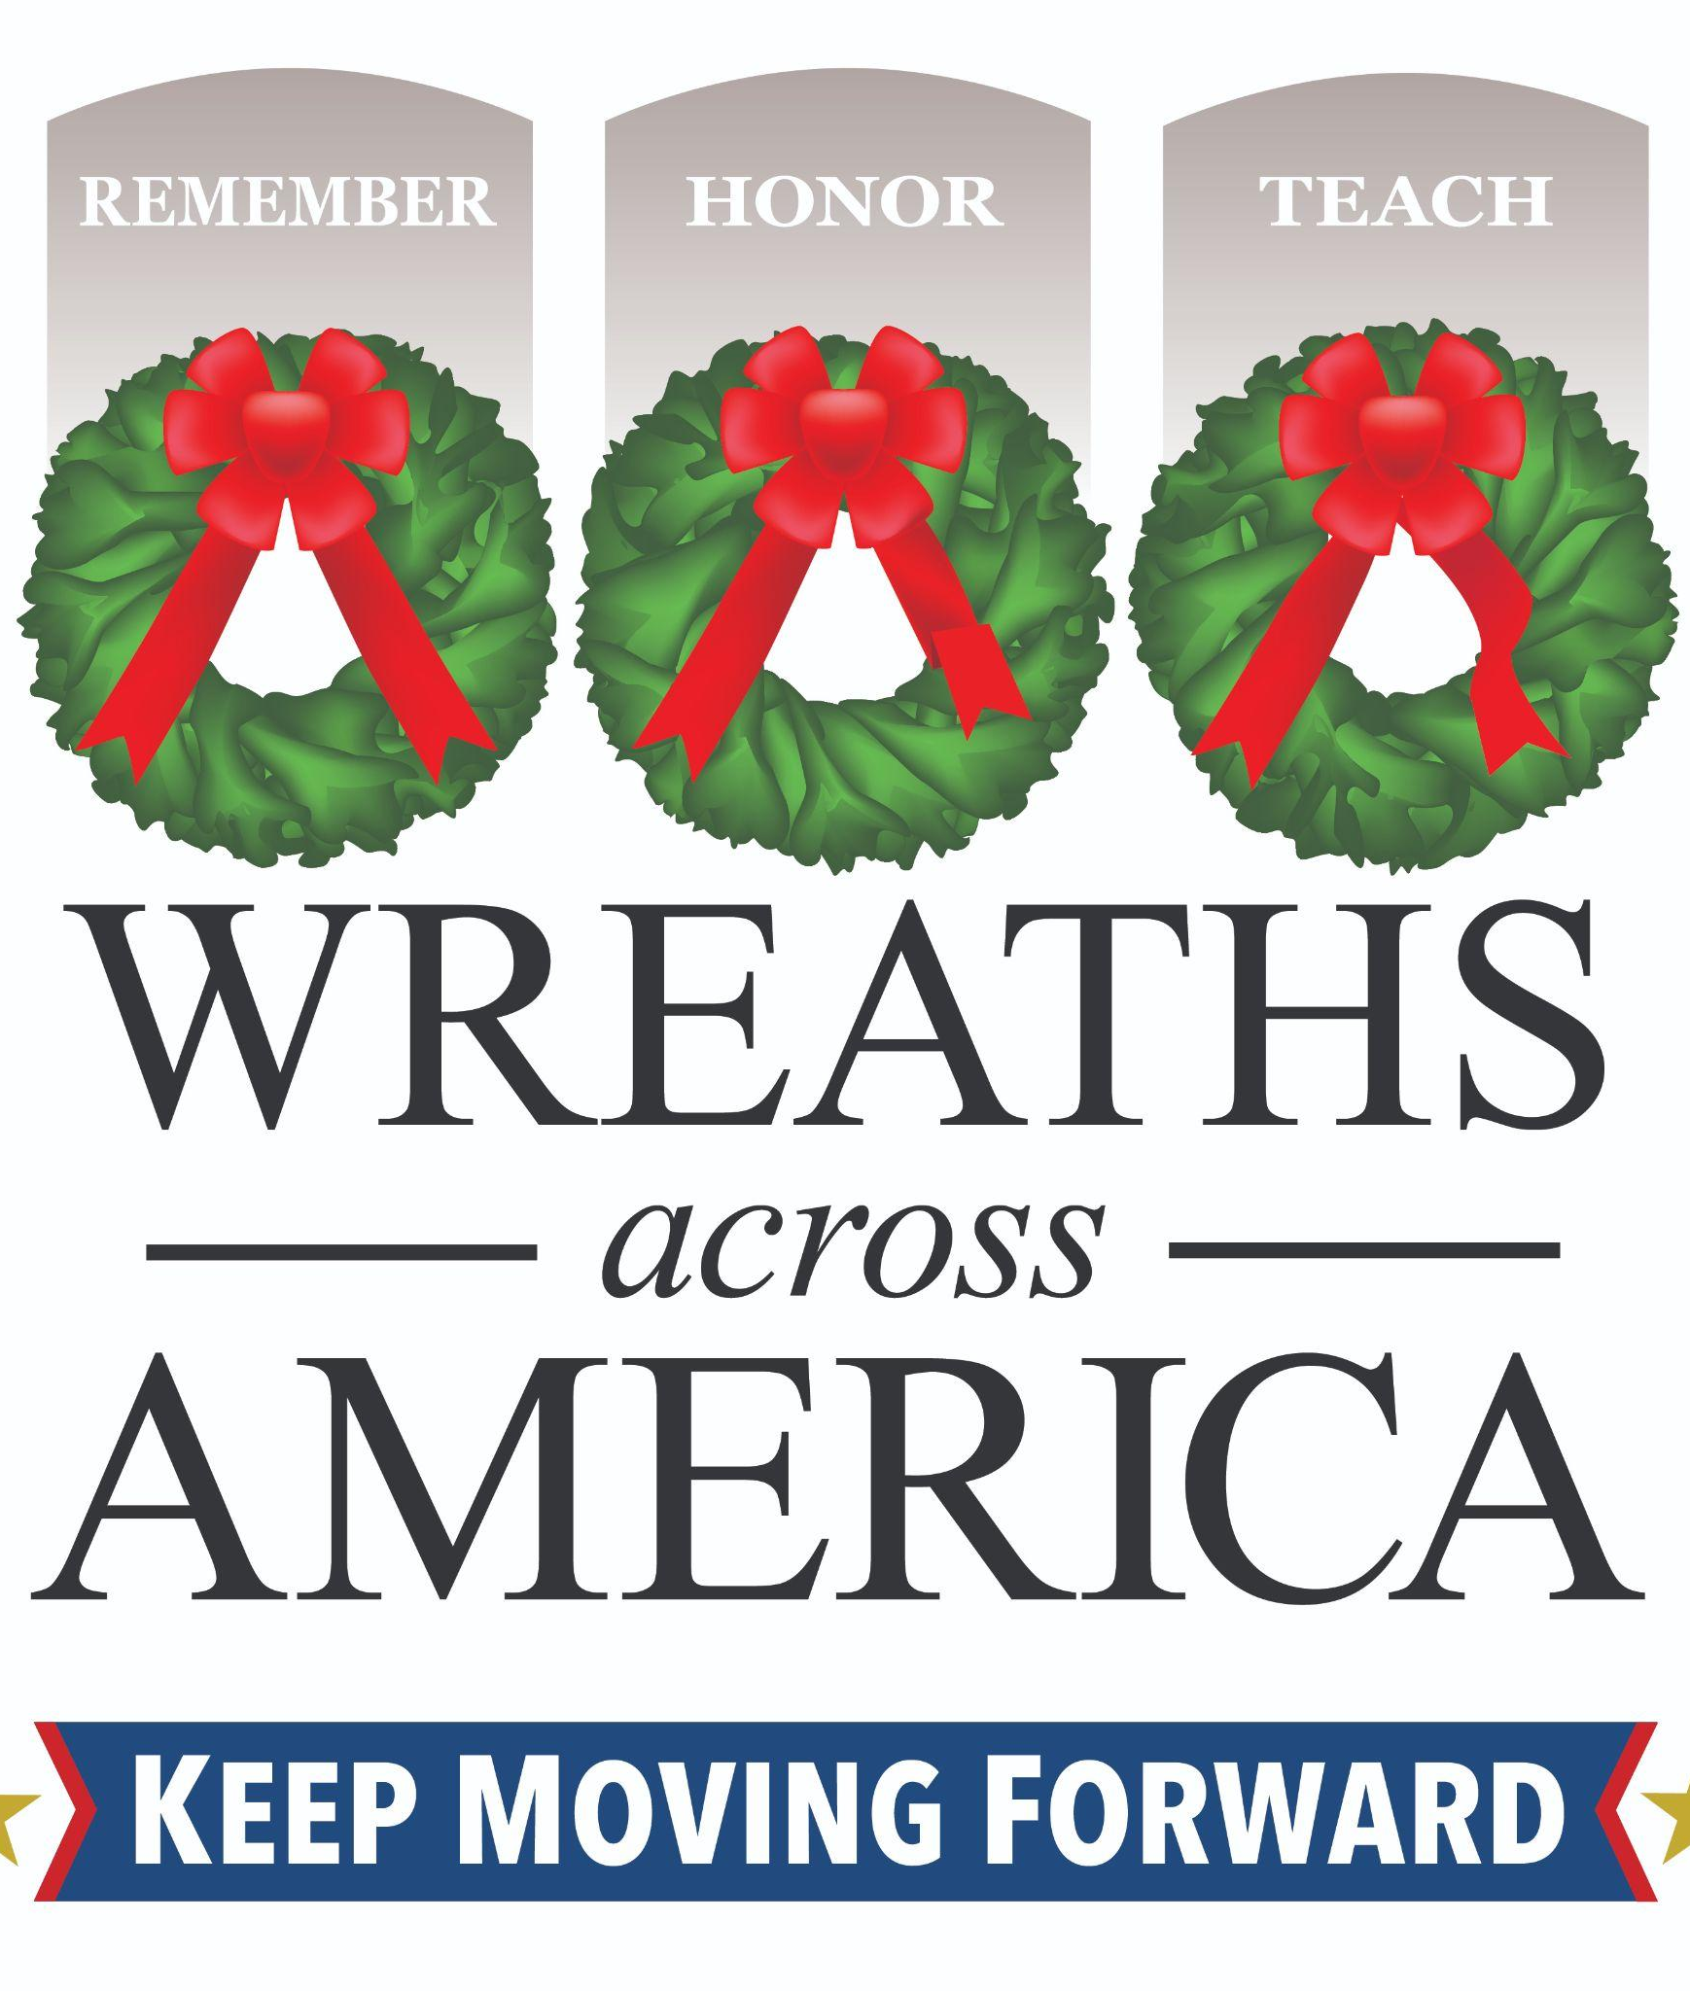

Example letter to company executive/business owner

Company/Business Name
Address
Date

Dear [name of owner or direct contact you have]:

In December 1992, Morrill Worcester, a wreath maker from Harrington, Maine, found himself with a surplus of 5,000 wreaths. Inspired by the desire to pay tribute to our nation’s veterans, Morrill, with the help of former Maine Senator Olympia Snowe, arranged for the wreaths to be placed at Arlington National Cemetery. This simple act of remembrance blossomed into an annual tradition that continues to honor veterans across the country.
In 2007, the Worcester family, alongside veterans and volunteers, founded the nonprofit Wreaths Across America to expand this effort and support communities across the U.S. In 2024, thanks to the dedication of more than 4 million volunteers, nearly 3.1 million veterans’ wreaths were sponsored and placed at 4,909 participating cemeteries in all 50 states, at sea, and abroad!
However, many veterans’ graves are still left bare. This year, we’re focused on increasing our impact locally and ensuring no veteran is forgotten. With your help, we can honor more heroes in our community and continue to grow this meaningful tradition.
You’re invited to join us in honoring our local veterans on National Wreaths Across America Day, Saturday, December 13, 2025. A remembrance ceremony will begin at [time], followed by the placement of veterans’ wreaths at [cemetery] located at [cemetery address], where [# of veterans interred] servicemembers are laid to rest. This meaningful event is open to all who wish to attend and take part in remembering those who served and sacrificed.
In 2024, approximately [# of sponsored wreaths] veterans’ wreaths were placed to honor our nation’s heroes at [cemetery name], leaving [# of veterans interred minus # of sponsored wreaths] servicemembers without a wreath placed. This year, we aim to ensure that every one of the [# of veterans interred or goal] servicemembers laid to rest here receives a fresh, handmade veteran’s wreath as a symbol of remembrance and gratitude. Each wreath costs $17 to sponsor and is made in the United States with Maine balsam.
We hope [Company Name] will consider joining our mission in one of the following ways: by sponsoring wreaths, making a grant or corporate donation, matching employee contributions, or donating in-kind support such as equipment, materials, or services for the event. Your support will make a meaningful difference to families, volunteers, and communities who gather each December to say each person’s name out loud and honor their service.
On behalf of the volunteers, military families, and the entire Wreaths Across America community, thank you for considering this meaningful and patriotic cause. We welcome the opportunity to discuss how [Company Name] can support the mission to Remember, Honor, and Teach at [cemetery name]. I’ll follow up soon to answer any questions and explore the best way for your team to get involved. In the meantime, please don’t hesitate to reach out if you’d like to set up a time to talk or request additional information.

Respectfully,

WAA Volunteer / Group or Location Name
Email address and/or phone number
DON’T FORGET TO INCLUDE YOUR GROUP OR LOCATION DIRECT LINK

