TEMPLATE

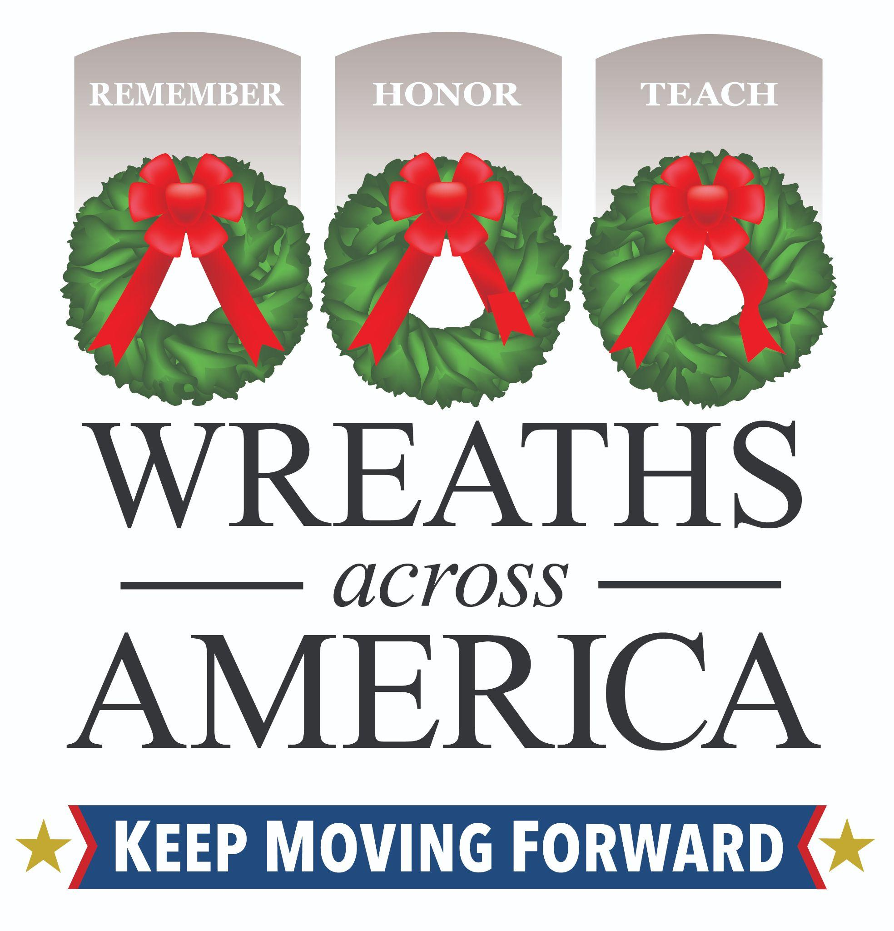

Wreaths Across America Announces Top Sponsorship Groups in [State]
Local volunteer efforts honored more than [number of vets] [State] servicemembers laid to rest on Wreaths Across America Day 2024

COLUMBIA FALLS, Maine and CITY, State abbr. – Month XX, 2025 – Each year, national nonprofit Wreaths Across America (WAA) recognizes top sponsorship groups for excellence in serving their local communities while helping to share the yearlong mission to Remember, Honor and Teach. Among the thousands of supportive groups honoring interred veterans through wreath sponsorships, WAA recognizes the top five sponsorship groups for their meaningful contribution in 2024.

[State’s] top five sponsorship groups of 2024 include:

- Group Name (groupID) - [# of sponsorships]
- Group Name (groupID) - [# of sponsorships]
- Group Name (groupID) - [# of sponsorships]
- Group Name (groupID) - [# of sponsorships]
- Group Name (groupID) - [# of sponsorships]

Combined, these groups honored (total number) interred servicemembers at XX participating locations throughout [State] on National Wreaths Across America Day in 2024.

Since its founding in 2007, WAA has collaborated with hundreds of like-minded organizations, volunteers, and civic groups nationwide to remember and honor our nation’s veterans. Through its national 3-for-2 sponsorship group program, an additional wreath was placed for every two sponsored. Through WAA’s national $5 back program, wreath sponsorships made an even more significant impact on communities—with $5 of each $17 wreath sponsorship made through a registered WAA sponsorship group, enabling them to support local programs and initiatives even more. WAA has given back $28 million in local contributions through this national program over the last 17 years!

“I have long said it would be disingenuous for us as an organization whose mission is to Remember the fallen, Honor those who serve, and Teach the next generation the value of freedom if we do not support other like-minded programs doing just that in their communities,” said WAA Executive Director Karen Worcester. “The Sponsorship Group Program is a great way to support the programs doing good work in your area all year while honoring as many veterans as possible!”

To find a sponsorship group to support in your community in 2025, please click here. It is never too early to join the mission and support these local efforts.

This year, National Wreaths Across America Day will be held on Sat., Dec. 13, 2025. Each $17 sponsorship supports WAA’s year-round mission and the many free programs designed to share it with communities nationwide. In addition, a live balsam wreath will be placed in remembrance on the headstone of an American hero.

# # #

About Wreaths Across America
Wreaths Across America is a 501(c)(3) nonprofit organization founded to continue and expand the annual wreath-laying ceremony at Arlington National Cemetery begun by Maine businessman Morrill Worcester in 1992. The organization’s yearlong mission – Remember, Honor, Teach – is carried out in part each year by coordinating wreath-laying ceremonies in December at Arlington, as well as at thousands of veterans’ cemeteries and other locations in all 50 states and beyond.

For more information or to sponsor a wreath, visit www.wreathsacrossamerica.org.

WAA National Office:
Rachael Wilson, PR Coordinator
Wreaths Across America
rwilson@wreathsacrossamerica.org
(207) 230-4599

Please visit our Media Resources Page to download background, photos, logos, or other items to help you file your story. Please credit all imagery to WAA Staff. Additional press photos and video can be available via email request at rwilson@wreathsacrossamerica.org.

