Thank youfor coming today to help us lay wreaths in honor of our veterans!

You can pick up veterans’ wreaths <<Insert specific instructions on where to pick up and place the wreaths>>. As you place each wreath, please take a moment to say the veteran’s name aloud, keeping their memory alive.

Upright Headstones

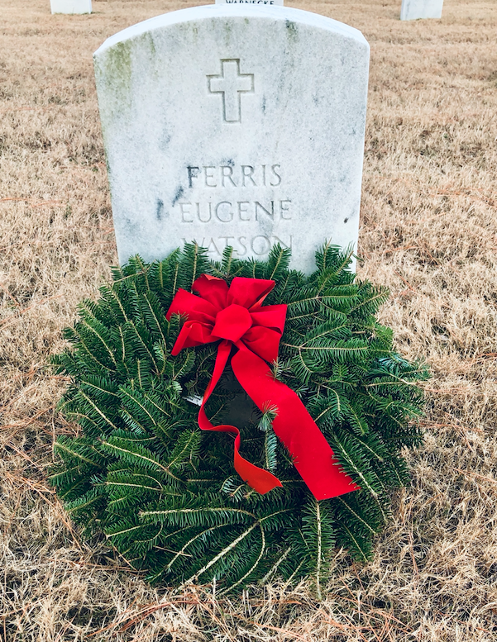

Place the wreath against the headstone, with the bow centered at the top.

*Ensure the veteran’s name remains visible.*

Flat Markers

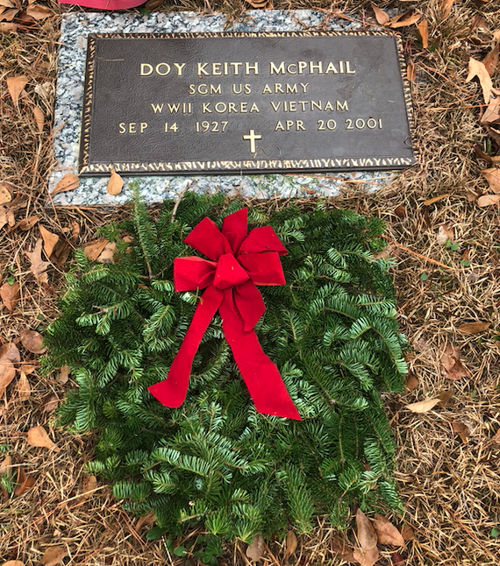

Lay the wreath flat on the ground, with the bow centered at the base of the marker.

*Ensure the veteran’s name remains visible.*

Important Guidelines

*Parents, Guardians, and Chaperones – Please communicate these instructions with your children participating today, to ensure they understand which gravesites should or should not receive a wreath.*

* Do not place your wreath on a grave that already has one, unless your wreath is specifically assigned to that grave.
* Do not move a wreath once it has been placed.
* In accordance with and out of respect for Jewish custom, which is not to place living flowers, wreaths or laurels on gravesites, do notplace wreaths on the headstones of servicemembers with a Star of David. Please take a moment to stop and say their name, but do not place a wreath. *(Important: If you come to a headstone with a Star of David and a wreath is already placed there, please leave it, as this may have been placed directly by family or friends.)*
* Respect other tributes: Do not remove any items already placed at headstones, such as other wreaths, flowers, or tokens left by family or friends.

Wreath Laying Procedure

* Receive the wreath and approach the headstone/marker, then extend the wreath outward as an offering to the veteran.
* Place the wreath centered on the headstone/marker, with the bow at the top, ensuring the veteran’s name is visible.
* Say the veteran's name aloud. *Military and Cadets: Render a slow salute or place your right hand over your heart.*

Feel free to take a tag from the back of the wreath as a memento of your efforts today. With over {{Insert number}} of veterans laid to rest at {{insert cemetery name}}, we could not do this without you!

THANK YOU for helping us REMEMBER, HONOR, and TEACH on National Wreaths Across America Day!



To all WAA Volunteers:

Thank you for being here today…

Before you get started, there are some items to be brought to your attention, to make your experience even better.

1) Each wreath you’ll be placing is handmade and unique. They are made of balsam fir grown in the Downeast region of Maine, USA, with pride.

2) Some of the needles do become detached during the making, packing, and transportation of the wreaths. Please keep in mind that every wreath has tens of thousands of needles, and it is normal for this to happen.

3) Because the wreaths are packed tightly in boxes, it will take 2-3 hours for them to fully relax to their natural circular shape.

4) Before placing a wreath on a headstone, take a minute to re-fluff the greens and rearrange the bow.  When the wreath is finally laid at the headstone, please make sure the bow is at the 12:00 position.

It is important to have that intimate moment with the hero you are honoring, but please remember to take a step back and look at the complete picture of what all of us have accomplished through the mission to REMEMBER, HONOR, and TEACH.

Again, thank you for your patriotism. Without you, National Wreaths Across America Day would not be so nice.

God Bless our Veterans and God Bless America.

With thanks,

Morrill Worcester

Founder, Wreaths Across America****