FOR IMMEDIATE RELEASE

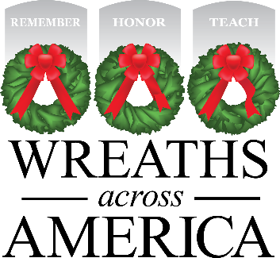

Local Wreaths Across America Event Planned for [time, date at location]

Volunteers help to Remember, Honor, Teach about our community’s heroes.

[YOUR CITY, State abbr.] — [Date], 2026 — Local Wreaths Across America volunteers are working hard to ensure that all veterans laid to rest [LOCATION] are honored this December as part of National Wreaths Across America Day – Saturday, December 19, 2026. In preparation for this annual event, [local group] is holding a [name of event] at [location] at [time] to raise awareness and sponsorships to honor every veteran laid to rest at [participating location].

[Insert details about your group’s involvement, is this your first year participating? How will this program support your local community, etc.?]

“Every $17 sponsorship made is a meaningful gift from a grateful American who knows what it means to serve and sacrifice for the freedoms we all enjoy,” said Karen Worcester, executive director of Wreaths Across America. “We are so grateful to the good people of this wonderful community for participating in our mission to Remember, Honor and Teach.”

Last year, ceremonies were held across the country at 5,598 participating locations, placing more than 3.1 million sponsored veterans’ wreaths for servicemembers laid to rest. This year Wreaths Across America Day will be held on Saturday, December 19, 2026.

The goal: place a live, balsam veteran’s wreath at the headstone of every American servicemember to Remember their sacrifice, Honor their service, and Teach the next generation about the value of freedom. For more information, to donate or to sign up to volunteer, please visit www.wreathsacrossamerica.org/GROUPID.

# # #

About Wreaths Across America
Wreaths Across America is a 501(c)(3) nonprofit organization founded to continue and expand the annual wreath-laying ceremony at Arlington National Cemetery, which was begun by Maine businessman Morrill Worcester in 1992. The organization’s yearlong mission – Remember, Honor, Teach – is carried out in part by coordinating wreath-laying ceremonies in December in communities in all 50 states and beyond. Each $17 sponsorship supports far more than a single wreath. It fuels programs that honor veterans, teach future generations, and give back to communities nationwide. Visit www.wreathsacrossamerica.org to learn more about how you can get involved in your local community.

Press contacts:

Local POC Name
Email
Phone number

WAA PR Team
(207) 690-7548
pr@wreathsacrossamerica.org

NOTE TO MEDIA: Please visit the Media Resources Page to download background, photos, logos, or other items to help you file your story.

