FOR IMMEDIATE RELEASE

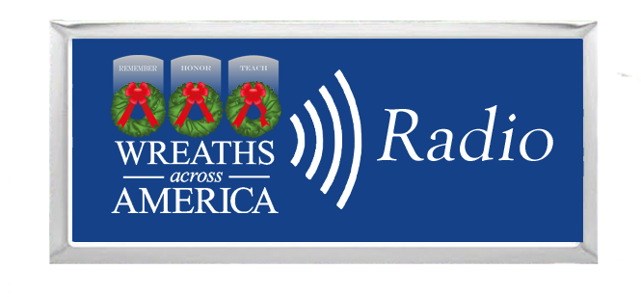

Wreaths Across America Radio Expands Programming to Over 50 Unique Shows
Local effort in [your city or town] supports this national program led by area volunteers.

COLUMBIA FALLS, Me., and [YOUR TOWN, State Abbr.] — [Date], 2024 — Wreaths Across America Radio, the leading internet radio station dedicated to honoring veterans and their families, proudly announces a significant expansion in its programming lineup. Locally, volunteers are bringing this national program to the area at [name the participating location you support].

With a commitment to providing diverse and engaging content, Wreaths Across America Radio now offers over 50 unique shows, including seven new veteran-centric programs. Since its inception, Wreaths Across America Radio has strived to amplify the voices of veterans, military families, and supporters nationwide. The addition of new shows underscores the station’s dedication to its mission to Remember, Honor, Teach.

New shows include 1 Mile 1 Veteran with Danny Mayberry, Bulletproof Podcast with Ace, Connect First with Command Sgt. Maj. Shawn Carns, America’s First Corps, PHIner Life Show from the Mu Beta Phi Military Fraternity, Inc., Transacting Value, and True War Stories. The seventh show, Modern MilSpouse, is a production of Wreaths Across America Radio in partnership with Armed Forces Insurance (AFI) and features Military Spouses of the Year as hosts. The new programming focuses on veteran and active-duty information and support, mental health issues, military life, and stories of everyday life as a military spouse.

In addition to veteran-centric content, Wreaths Across America Radio has added two new shows to its “Trucking Tuesday” lineup: Sense Per Mile with Charles Gracey and Paul Gibson, and Standing Out: A Podcast About Sales, Marketing, and Leadership with Trey Griggs. Throughout the week, the station is hosted by six Wreaths Across America Radio on-air personalities: “Morning Show” host Michael W. Hale; JR Kitchens, U.S. Navy veteran; Tony Sequeria, USMC veteran; Justin Manning, TSGT (ret) USAF; Chuck Igo, U.S. Navy veteran; and New York on-air personality Mike Patrick.

“As Wreaths Across America Radio continues to expand our programming, we are honored to partner with shows that honor veterans and support the military community,” said Jeff Pierce, Director of Broadcast and Media Partnerships at Wreaths Across America Radio. “We are dedicated to continually providing a platform for veterans, military families, and our volunteers to share their stories and support.”

For a complete list of programming and to tune in to Wreaths Across America Radio, please visit https://www.wreathsacrossamerica.org/radio. The station can also be heard on the iHeartRadio, Audacy, and TuneIn apps.

For more information or to sponsor a wreath to support [NAME OF GROUP OR LOCATION], please visit [www.wreathsacrossamerica.org/YOURID]. Your $17 sponsorship will support the program and place a fresh balsam veteran’s wreath on the headstone of an American hero on December 14, 2024, as part of National Wreaths Across America Day.

# # #

About Wreaths Across America Radio
Wreaths Across America Radio is a 24/7 Internet stream. Its unique format provides informational and inspiring content about members of the U.S. armed forces, their families, military veterans, and volunteers throughout the country and overseas who support the mission to Remember, Honor, Teach. Along with the inspiring content, Wreaths Across America Radio plays various music with roots firmly planted in patriotism and a country music thread running through the core of the stream. Wreaths Across America Radio has a live morning show every weekday morning from 6 am to 10 am ET, along with a variety of special programs that support the mission.

You can listen to Wreaths Across America Radio’s 24/7 internet stream anytime and anywhere on the iHeart Radio app, Audacy app, TuneIn app, or at www.wreathsacrossamerica.org/radio.

Press contacts:

Local Contact
Your Name
email address
phone-number

National WAA Contact:
Sean Sullivan
(207) 230-4599
ssullivan@wreathsacrossamerica.org

NOTES TO MEDIA AND PRESS MATERIALS:
Please visit our Media Resources Page to download background, photos, logos, or other items to help you file your story. Interview opportunities are available.

