FOR IMMEDIATE RELEASE

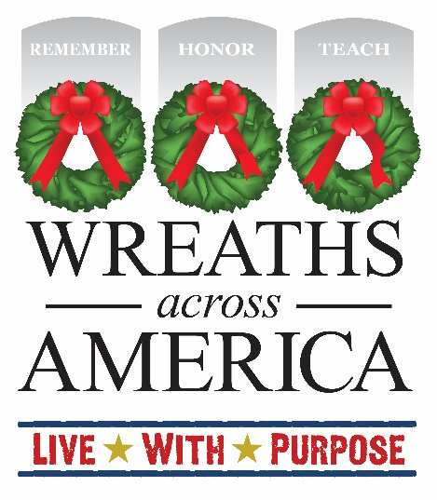

Local [Group or Volunteer Name] From [Region] Receives National Attention!

[Your Area] Volunteer to be a featured national guest on Wreaths Across America Radio.

COLUMBIA FALLS, Me., and [YOUR TOWN, State Abbr.] — [Date], 2024 — Local volunteer [your name], who is a [Sponsorship Group Leader/Location Coordinator] supporting the Wreaths Across America (WAA) program at [Participating Location], will be featured in a national interview on Wreaths Across America Radio. The interview will air on [DATE] at [TIME] and offer listeners nationwide the chance to learn more about local efforts supporting the year-round mission to Remember, Honor and Teach.

Wreaths Across America Radio regularly features interviews with volunteers from across the country, highlighting their charitable efforts in their local community. Since its founding in 2007, WAA has partnered with hundreds of like-minded charities, community programs, and civic groups nationwide to Remember the fallen, Honor those who serve, and Teach the next generation the value of freedom. Wreaths Across America Radio celebrates the work being done by volunteers and groups like [your group] to inspire others to serve in their communities.

[INSERT QUOTE FROM YOU OR ANOTHER LOCAL VOLUNTEER ABOUT PARTICIPATING OR LOCAL DETAILS YOU WANT TO SHARE FOR YOUR COMMUNITY THIS YEAR.]

Wreaths Across America Radio is a 24/7 Internet stream. Its unique format provides informational and inspiring content about members of the U.S. armed forces, their families, military veterans, and volunteers throughout the country and overseas who support the mission to Remember, Honor and Teach. Along with the inspiring content, Wreaths Across America Radio plays a variety of music with roots firmly planted in patriotism and a country music thread running through the core of the stream. Wreaths Across America Radio has a live morning show every weekday from 6 am to 10 am ET. It features more than 50 special programs on topics important to veterans and military families.

You can listen to Wreaths Across America Radio’s 24/7 internet stream anytime and anywhere on the iHeart Radio app, Audacy app, TuneIn app, or at www.wreathsacrossamerica.org/radio.

For more information or to sponsor a wreath to support [NAME OF GROUP OR LOCATION] please visit [www.wreathsacrossamerica.org/YOURID]. Each individual $17 sponsors a fresh balsam veteran’s wreath that will be placed on the headstone of an American hero on December 14, 2024, as part of National Wreaths Across America Day.

# # #
About Wreaths Across America
Wreaths Across America is a 501(c)(3) nonprofit organization founded to continue and expand the annual wreath-laying ceremony at Arlington National Cemetery, which was begun by Maine businessman Morrill Worcester in 1992. The organization’s yearlong mission – Remember, Honor, Teach – is carried out in part each year by coordinating wreath-laying ceremonies in December at Arlington, as well as at thousands of veterans’ cemeteries and other locations in all 50 states and beyond. To learn more, visit www.wreathsacrossamerica.org.
Press contacts:

Local Contact
Your Name
email address
phone-number

National WAA Contact:
Sean Sullivan
(207) 230-4599
ssullivan@wreathsacrossamerica.org

NOTES TO MEDIA AND PRESS MATERIALS:
Please visit our Media Resources Page to download background, photos, logos, or other items to help you file your story. Interview opportunities are available.

