FOR IMMEDIATE RELEASE
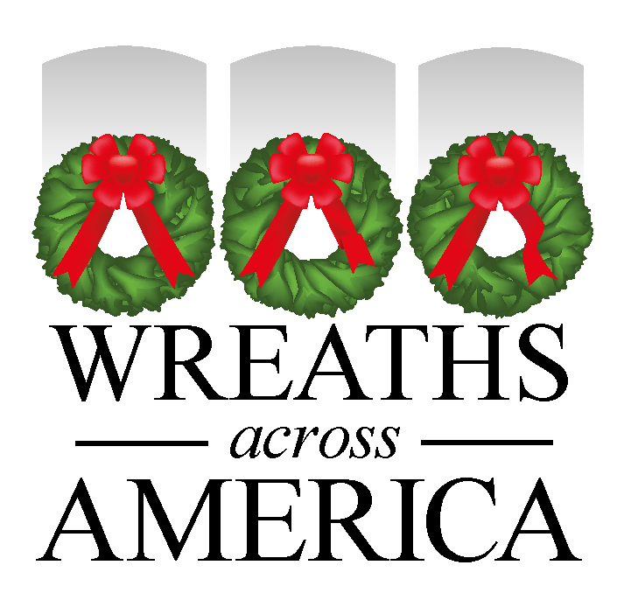

National Nonprofit Wreaths Across America Announces New Theme for 2024

“Live with purpose”

COLUMBIA FALLS, Maine, and [CITY, State]— January XX, 2024 — Wreaths Across America (WAA), the national nonprofit whose year-long mission is to Remember the fallen, Honor those who serve, and Teach our children the value of freedom, proudly announces its theme for 2024: “Live with Purpose.”

Each year, millions of volunteers and patriots gather in local, state, and national cemeteries across all 50 states and abroad states - most recently at [insert Participating Location] - to pay tribute to our veterans. This year’s theme, “Live with Purpose,” draws inspiration from the remarkable stories of Wreaths Across America volunteers whose impactful work in their communities is a beacon of inspiration for all.

“Over the course of the last year, and then especially on the escort to Arlington last December, I listened to people who had gone through great adversity, and they'd taken that adversity and turned it around as a call to action to spend the rest of their lives making sure that every day was meaningful and that they lived with purpose,” said Worcester. “For me, live with purpose is a mindset.”

As part of this year’s theme, WAA will be sharing a monthly video series and corresponding lesson plans starting in February that speak to the 10 bouquets that make up a veteran’s wreath – these are the 10 attributes or characteristics that WAA believes define our nation’s servicemembers – a symbol of honor, respect and victory.

[Insert local quote from volunteer about the efforts or your local community and how you will work to highlight stories in line with this year’s theme in 2024. Please remember to include a direct link to your fundraising/location page www.wreathsacrossamerica.org/YOURID]

In 2023, over three million sponsored veterans’ wreaths were placed by volunteers on headstones at 4,224 participating locations worldwide. Wreaths Across America volunteers tirelessly work year-round to Remember, Honor, and Teach, with each name spoken out loud in grateful acknowledgment of the sacrifices made by our veterans for our freedoms.

Follow the impactful stories of those volunteers and supporters living with purpose throughout the year using the hashtag #LiveWithPurpose and tune in to Wreaths Across America Radio, available on the iHeart Radio app, TuneIn, and the Audacy app, or listen at www.wreathsacrossameric.org/radio.
This year, National Wreaths Across America Day will be held on Saturday, December 14, 2024. This is a free event open to all, and the organization encourages community members to participate by volunteering locally or sponsoring a wreath for an American hero.

For more information, please visit www.wreathsacrossameric.org/YOURID.

# # #
About Wreaths Across America
Wreaths Across America is a 501(c)(3) nonprofit organization founded to continue and expand the annual wreath-laying ceremony at Arlington National Cemetery, which was begun by Maine businessman Morrill Worcester in 1992. The organization’s mission – Remember, Honor, Teach – is carried out in part each year by coordinating wreath-laying ceremonies in December at Arlington, as well as thousands of veterans’ cemeteries and other locations in all 50 states and beyond.
For more information or to sponsor a wreath, please visit www.wreathsacrossamerica.org.
Press contacts:
Local Contact
Name
Phone #
Email address
National Contact
Sean Sullivan
(207) 230-4599
ssullivan@wreathsacrossamerica.org
NOTES TO MEDIA AND PRESS MATERIALS:
Please visit our Media Resources Page to download background, photos, logos, or other items to help you file your story.
Interview opportunities are available.

