FOR IMMEDIATE RELEASE
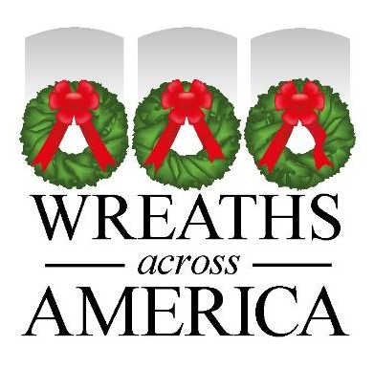

Wreaths Across America Invites All [location] Community Members to Wave the Flag on September 12th

Local volunteers, Gold Star families, veterans, first responders and their families will all be taking part in a national flag-waving event intended to recapture the American pride and unity felt on Sept. 12, 2001.

COLUMBIA FALLS, Maine and [CITY, State Abbr.] – August XX, 2023 – On Tuesday, September 12, 2023, between 9-10 am ET, the [WAA Location or Group WAA] is calling for the residents of [local area] to join in flag-waving to remind all Americans of the feeling we had – the pride in country, the unity and patriotism – which was expressed on the days following 9/11/01. In addition to local efforts, a national event will be hosted LIVE on WAA’s official Facebook page and broadcast over Wreaths Across America Radio. The broadcasts will include interviews and stories from volunteers, supporters, Gold Star families, veterans, first responders and members of the next generation.

[Insert details to where local flag-waving will occur in the community.]

WAA gathers every Tuesday morning from 9-10 am ET to raise the American flag and say the Pledge of Allegiance from the Freeport Flag Ladies Monument on Route 1 in Jonesboro, Maine, near the ‘tip lands’ where balsam is harvested to make veterans’ wreaths for placement on National Wreaths Across America Day each December. The monument was built by WAA in partnership with its founder Morrill Worcester, in September 2019, after the Freeport Flag Ladies retired following 18 years of waving the American Flag in Freeport, Maine, each Tuesday since September 11, 2001.

“Now, more than ever, it is so critical for communities to come together to remember all those who served, and honor their service and their family’s service, especially those who volunteered during the War on Terror following the events of September 11, 2001,” said WAA Executive Director, Karen Worcester. “But more than anything, we must teach our children about these men and women, and the courage and commitment it takes to be a part of the small number of Americans who protect all our freedoms. Please join us on September 12, as we wave the American flag proudly, like we do each Tuesday morning, and never forget that freedom isn’t free and must be protected.”

[Insert quote from local volunteer as to why they feel it is important for the community to participate.]

WAA encourages the American public to join this weekly tradition starting on September 12 by sharing their pictures and videos on social media using the hashtag #FlagsAcrosstheCountry. You can also submit videos and photos easily on the following link: http://WreathsAcrossAmerica.memfox.io/flagwaving. Follow WAA on Facebook, share where you are participating, and share on your own social channels.

You can support the local WAA program at [Participating Location] by visiting www.wreathacrossamerica.org/YOURID. Each $17 sponsorship goes toward a live balsam wreath that will be placed on the headstone of an American hero as we endeavor to honor all veterans laid to rest on Saturday, December 16, 2023, as part of National Wreaths Across America Day.
# # #

About Wreaths Across America
Wreaths Across America is a 501(c)(3) nonprofit organization founded to continue and expand the annual wreath-laying ceremony at Arlington National Cemetery begun by Maine businessman Morrill Worcester in 1992. The organization’s mission – Remember, Honor, Teach – is carried out in part each year by coordinating wreath-laying ceremonies in December at Arlington, as well as thousands of veterans’ cemeteries and other locations in all 50 states and beyond.
For more information or to sponsor a wreath, please visit www.wreathsacrossamerica.org.

Press contacts:
Sean Sullivan
(207) 230-4599
ssullivan@wreathsacrossamerica.org

Local POC
Email
Phone Number

NOTES TO MEDIA AND PRESS MATERIALS:

Please visit our Media Resources Page to download background, photos, logos, or other items to help you file your story.

Interview opportunities will be available leading up to and on Sept. 12th.

What is a Veteran’s Wreath?
https://www.youtube.com/watch?v=5_-EW6a_VAs

