FOR IMMEDIATE RELEASE

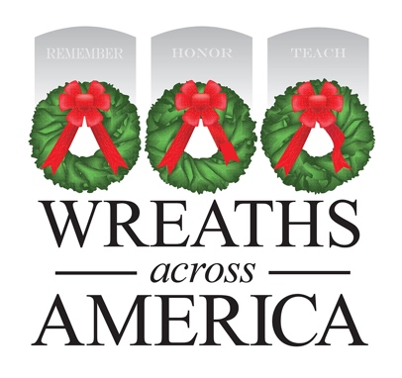

MEDIA ADVISORY
PHOTO/VIDEO OPPORTUNITY

Local Wreaths Across America Sponsorship Group to Host [EVENT]

WHAT: [Group name] is fundraising to support the Wreaths Across America program and event being held locally at [location]. They will be hosting an event at [location, include address] to bring awareness to the yearlong mission of the organization, which is to Remember the fallen, Honor those who serve, and Teach the next generation the value of freedom.

[Customize: Add information about the specific event — such as what’s involved and if the public can attend — and try to note any interesting visuals for broadcast media.]

WHEN: [Date + Time]

WHERE: [Address]

WHO: [List anyone attending who the media could interview or who might draw the media’s interest.]

# # #

About Wreaths Across America
Wreaths Across America is a 501(c)(3) nonprofit organization founded to continue and expand the annual wreath-laying ceremony at Arlington National Cemetery, which was begun by Maine businessman Morrill Worcester in 1992. The organization’s yearlong mission – Remember, Honor, Teach – is carried out in part by coordinating wreath-laying ceremonies in December in communities in all 50 states and beyond. Each $17 sponsorship supports far more than a single wreath. It fuels programs that honor veterans, teach future generations, and give back to communities nationwide.
Visit www.wreathsacrossamerica.org to learn more about how you can get involved in your local community.
Press Contacts:
Local Contact
Name
Phone #
Email address
National contact
WAA PR Team
(207) 690-7548
pr@wreathsacrossamerica.org
NOTES TO MEDIA: Please visit the Media Resources Page to download background, photos, logos, or other items to help you file your story.

