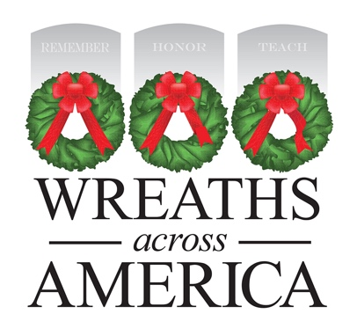
2024 Media Advisory Template
MEDIA ADVISORY
PHOTO/VIDEO OPPORTUNITY
National Wreaths Across America Day to be Held at [Cemetery Location]
WHAT: [Cemetery name], an official Wreaths Across America (WAA) location, will host a wreath-laying ceremony, joining more than 4,225 other locations across the country for National Wreaths Across America Day. Coordinated and led by local volunteers, sponsorship groups have raised funds throughout the year to sponsor the placement of [#] veterans’ wreaths on the headstones of our fallen service members laid to rest there. This annual event seeks to further the yearlong mission to Remember, Honor, Teach, ensuring that the memory of those who served our country endures.
WHEN: Saturday, December 14, 2024
Please specify times for wreath placement and ceremony if hosting both events.

WHERE:
[Cemetery name and specific location of ceremony]
[Address]

WHO:
[Military dignitaries/officers]
[Local dignitaries (e.g., state representative, governor, city councilors)]
Veterans, active service members and families

# # #
About Wreaths Across America
Wreaths Across America is a 501(c)(3) nonprofit organization founded to continue and expand the annual wreath-laying ceremony at Arlington National Cemetery, which was begun by Maine businessman Morrill Worcester in 1992. The organization’s yearlong mission – Remember, Honor, Teach – is carried out in part each year by coordinating wreath-laying ceremonies in December at thousands of veterans’ cemeteries and other locations in all 50 states and beyond.

For more information or to sponsor a wreath, please visit www.wreathsacrossamerica.org.

Press contacts:
Local contact
Name
Phone #
Email address
National contact
Sean Sullivan
(207) 230-4599
ssullivan@wreathsacrossamerica.org
NOTES TO MEDIA AND PRESS MATERIALS:
Please visit our Media Resources Page to download background, photos, logos, or other items to help you file your story.
Interview opportunities are available.

