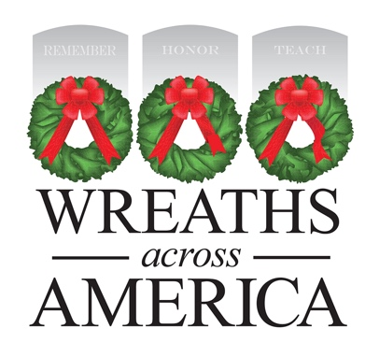
MEDIA ADVISORY
PHOTO/VIDEO OPPORTUNITY

Local Wreaths Across America Sponsorship Group to Host [EVENT]
WHAT: [Group name] is fundraising to support the Wreaths Across America being held locally at [location]. They will be hosting an event at [location, include address] to bring awareness to the yearling mission of the organization which is to Remember the fallen, Honor those who serve, and Teach the next generation the value of freedom.
[Add a line or two about the specific event — such as what’s involved and if the public can attend — and try to note any interesting visuals for broadcast media.]
WHEN: [Date + Time]
WHERE: [Address]
WHO: [List anyone attending who the media could interview or who might draw the media’s interest.]
# # #
About Wreaths Across America
Wreaths Across America is a 501(c)(3) nonprofit organization founded to continue and expand the annual wreath-laying ceremony at Arlington National Cemetery, which was begun by Maine businessman Morrill Worcester in 1992. The organization’s yearlong mission – Remember, Honor, Teach – is carried out in part each year by coordinating wreath-laying ceremonies in December at thousands of veterans’ cemeteries and other locations in all 50 states and beyond.

For more information or to sponsor a wreath, please visit www.wreathsacrossamerica.org.
Press contacts:
Local Contact
Name
Phone #
Email address
National contact
Sean Sullivan
(207) 230-4599
ssullivan@wreathsacrossamerica.org
NOTES TO MEDIA AND PRESS MATERIALS:
Please visit our Media Resources Page to download background, photos, logos, or other items to help you file your story.
Interview opportunities are available.

