


2023 Wreath Sponsorship Grave Specific Order Form
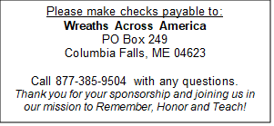
Sponsored wreaths are placed on grave markers at state and national veterans’ cemeteries, as well as at local and community cemeteries each December for National Wreaths Across America Day.

Your donation will ensure the placement of a veteran’s wreath for one or more veterans laid to rest at the participating location of your choice.

All sponsored veteran wreaths are shipped directly to the location selected by the sponsor on this form. Wreaths are not shipped to individual wreath sponsors.

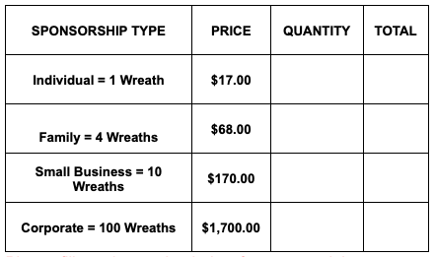
For quicker processing and the convenience of paying with a credit card, debit card, Google Pay, or PayPal, veteran wreaths may be sponsored online by scanning the QR Code above or by visiting: {{WAA Shortlink}}

You should be the only one to enter your credit card information at checkout on the Wreaths Across America website. For your security, do not share this information with anyone else who offers to place an order for you. To verify the validity of the QR Code, always check that wreathsacrossamerica.org is part of the web address when sponsoring wreaths online.

If you prefer to pay with a check, please complete this form and mail it along with your check to Wreaths Across America at the address listed in the box above.

To split your donation between multiple groups and/or locations, please list the IDs and dollar amounts for each.
CHECK # |  | CHECK DATE |  | SPONSOR NAME FOR DISPLAY  If different than name on check.
GROUP ID(s) | {{Group ID}} |  |  | EMAIL ADDRESS
LOCATION ID(s) | {{Location ID}} |  |  | PHONE #
DOLLAR AMOUNTS(s) |  |  |  | MAILING ADDRESS

SPECIAL REQUESTS
Please note in memory/honor of requests do not place a wreath on a specific loved one’s grave.
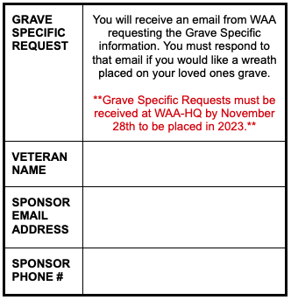
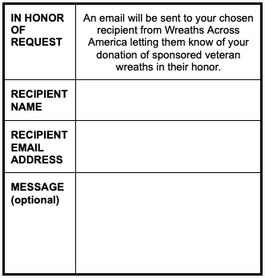
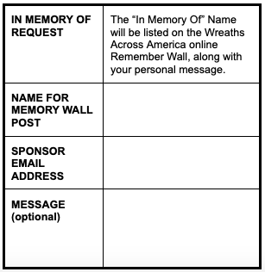

Thank you for supporting our mission to REMEMBER, HONOR, and TEACH!

