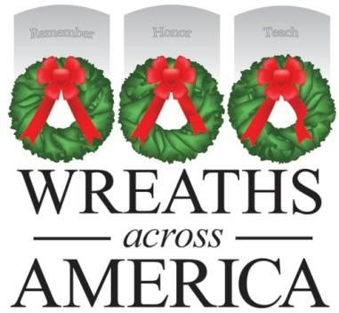
P.O. BOX 249 COLUMBIA FALLS, ME 04623 PHONE: 207-470-0967
TOLL FREE: 877-385-9504

www.WreathsAcrossAmerica.org

DATE

Dear NAME,

Thank you for being so willing to volunteer your services to Wreaths Across America and specifically to LOCATION NAME.

We are grateful for your community service efforts of # hours to help place wreaths on veterans’ graves on National Wreaths Across America Day, December 17th, 2022.

Your help, along with that of many others, allowed us to carry on the mission of Remember, Honor, & Teach at over 3,702 participating locations for National Wreaths Across America Day!

Should you have any questions about your volunteer service for Wreaths Across America, please don’t hesitate to let me know. We hope you will join us again in the future!

Sincerely,

LC or GL NAME
Volunteer Location Coordinator or Volunteer Group Leader
Wreaths Across America
www.wreathsacrossamerica.org



REMEMBER HONOR TEACH

