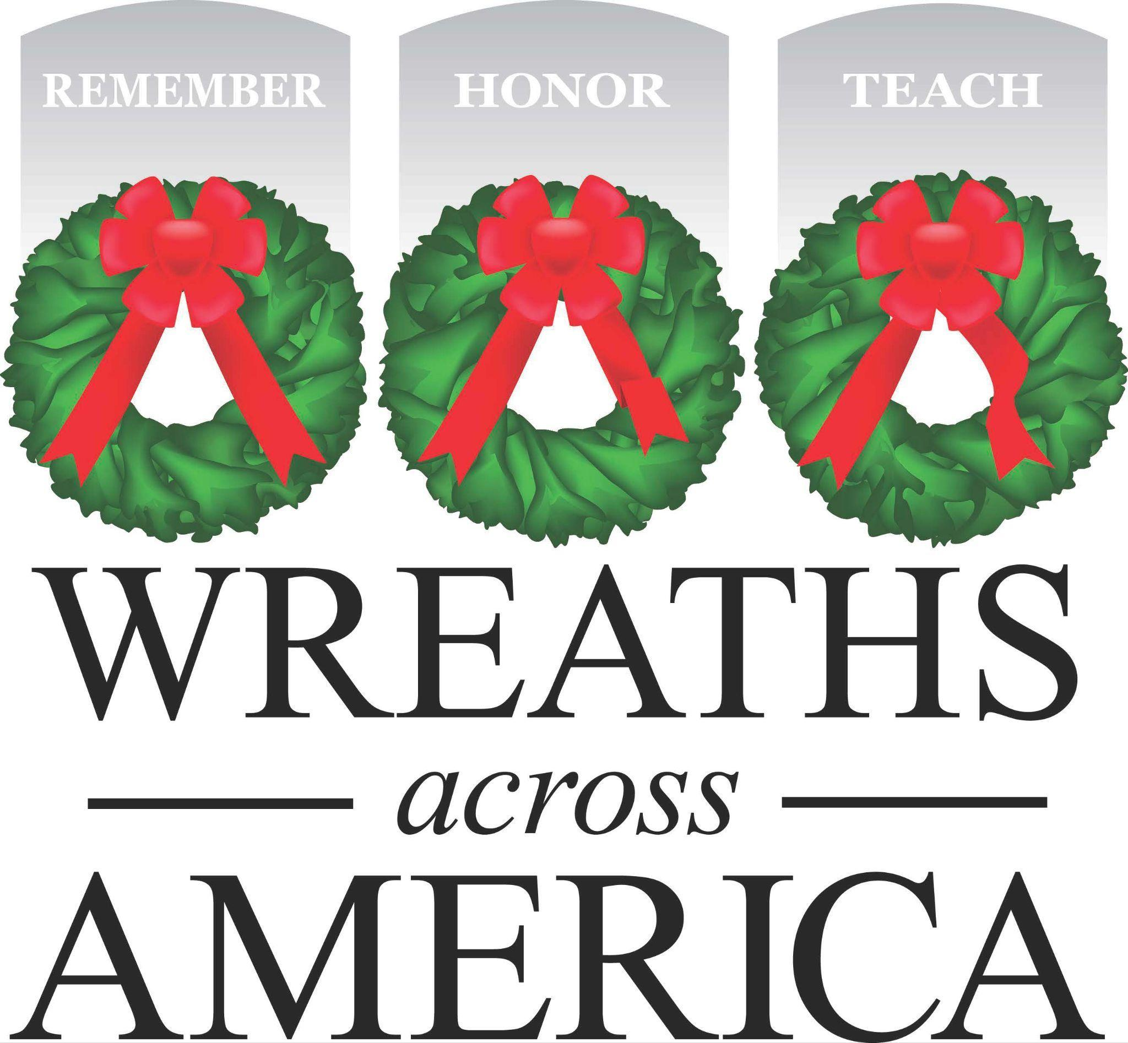

PROCLAMATION
Designating December 19, 2026 - National Wreaths Across America Day

WHEREAS, Wreaths Across America is a national nonprofit organization founded in 2007 to continue and expand the annual wreath-laying ceremony at Arlington National Cemetery begun by Maine businessman Morrill Worcester in 1992.

WHEREAS, Wreaths Across America’s yearlong mission is to REMEMBER the fallen, HONOR those who serve, and TEACH the next generation the value of freedom.

WHEREAS, Wreaths Across America is made up of more than 5,600 participating locations across the country run by dedicated volunteers looking to share the mission to Remember, Honor, and Teach, through annual wreath-laying ceremonies each December and free educational programs and community events that support veterans and military families throughout the year.

NOW, THEREFORE, I, OFFICIAL, TITLE, CITY, STATE, do hereby proclaim Saturday, December 19, 2026 as NATIONAL WREATHS ACROSS AMERICA DAY in the city of XXX and extend thanks and appreciation to our veterans, Gold Star and Blue Star Families for their service and sacrifice and to Wreaths Across America for bringing this honor to our community.

IN WITNESS WHEREOF, I have hereunto set my hand and caused the Seal of the CITY OF XXX to be affixed this DATE.

_______________________________________________
Name, Title

