REMEMBER HONOR TEACH
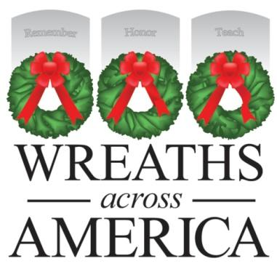

Company/Nonprofit Name
Address

Date

Dear [direct contact you have]:

It was December 1992 in Harrington, Maine, when wreath maker Morrill Worcester found himself with a surplus of 5,000 balsam wreaths during the holiday season. Mr. Worcester saw the surplus as an opportunity to pay tribute to our country’s veterans and arranged for the wreaths to be placed at Arlington National Cemetery. This annual tribute to our country’s veterans has continued ever since, touching the lives of millions of veterans’ families and volunteers and growing in scope through the years. What started as 5,000 wreaths at Arlington has grown to over 1.5 million veterans’ wreaths at more than 1,400 locations in all 50 U.S. states, at sea and abroad - including locally at [XYZ] cemetery in [TOWN].
Wreaths Across America invites you to Remember the fallen, Honor those that serve, and Teach the next generation about the value of freedom by becoming a local fundraiser of our Giving in July remembrance program. With your support, you can help us honor our nation’s veterans and all active duty military personnel. Through sale of wreaths sponsorships, your organization can each $5 back to support your own programs while helping us reach our goal of honoring all the [number] veterans buried at [local cemetery] this December. We are also encouraging area businesses to sign on for our “Giving in July”matching donation challenge, where you agree to match donations made by members of your community up to a certain amount throughout the month.
Through Giving in July, Wreaths Across America is inviting all Americans to remember our veterans and military families not only during the December holidays, but year-round. It is during the holidays that our deployed servicemen and women miss home the most and there are empty seats at family gatherings. It’s during the holidays that the heartache of losing a loved one seems the most profound. It's during the holidays when conflict and strife are replaced by charity and good will toward one another. Wreaths Across America wants the nation's service members thought of every day and for that kindness and goodwill to extend beyond the holiday season.
On behalf of the volunteers and military families looking to honor all the veterans in [LOCATION], and the Wreaths Across America extended family, I thank you for your consideration of this patriotic cause. I’ll be in touch to determine your interest in supporting the mission to Remember, Honor, Teach.

Respectfully,

Name
WAA Volunteer Title/Participating Cemetery Location
Contact info

DON’T FORGET TO INCLUDE YOUR GROUP OR LOCATION INFO TO GET CREDIT

***INFO ONLY For Location Coordinators and Fundraising Group Leaders***

- Donation options for businesses would be to set up a Fundraising Group page through WreathsAcrossAmerica.org and promote that link themselves to raise funds, or to contribute a lump sum donation directly to the program or through a Group.
- For nonprofits, the set up is the same and they get the $5 back for their own programs.
- If a business agrees to do a match during the month of July, they could say up to a specific amount and that would ensure their donation is the total of what they are willing to spend - however, often times if the public believes their donation will be amplified in some way, it can help spur giving.
- In exchange for a business or nonprofits support, you can offer to do a press release about their involvement and share with local media. WAA office will provide a template press release you can customize and share locally.
- Depending on the size of the sponsorship, you can also offer to do posts on your location social media pages highlighting the business/nonprofit for their support and/or add the business name and logo to your event program or promotions. This is entirely up to you and what visibility you have to offer.
- WAA Communications Director Amber Caron can help you talk through how best to promote businesses willing to support your local effort. Feel free to contact her with questions directly at acaron@wreathsacrossamerica.org; (207) 513-6457.

