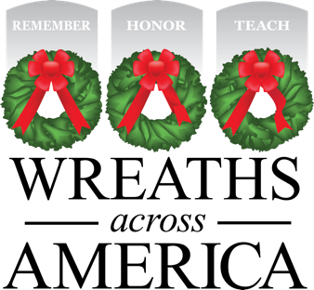

Wreaths Across America and [Fundraising Groups] Kick Off Annual Giving in July

Subhead options:

[LOCAL FUNDRAISING GROUP(s) and nonprofit team up to raise awareness and wreath sponsorships to honor local veterans buried at LOCATION this December]

[Specific event the local community has planned, e.g., To host Fourth of July/special event to benefit local wreath fundraising effort]

COLUMBIA FALLS, Maine and [YOUR CITY, State] — June/July xx, 2019 — National nonprofit Wreaths Across America (WAA) announces the kick off to Giving in July — a month dedicated to the groups and individuals giving back in their communities while helping to share the mission to Remember, Honor and Teach.
Too often we recognize deployed servicemen and women only as the holidays approach when their absence from home is felt most strongly. WAA’s Giving in July campaign helps to remind us that veterans and our current military serve and protect us 365 days a year. Like the well-known marketing campaign Christmas in July, considering our own charity during the summer months provides us the opportunity to encourage others to get involved early with the WAA mission and support our nation’s veterans in the communities they live throughout the year.
Locally, [Fundraising Group Name] has been a participating fundraising group for Wreaths Across America since [year], raising funds to honor the servicemembers buried at [Cemetery Name] with the placement of sponsored veterans’ wreaths made of fresh Maine balsam each December. Through WAA’s fundraising program, the sponsorship of a $15 veteran’s wreath through [Fundraising Group] ensures a wreath is placed and $5 of that sponsorship goes back to the group for use [to support programs in their community – identify if possible]. In sharing WAA’s mission locally, you are also helping the programs giving back within your own community. Or as we like to call it, you have the opportunity to “do good twice!”
[Insert any special promotions the Locations/Fundraising Groups have planned for July. This could include a partnership with a local business or fundraising events, links to Facebook events, etc.].
Over the last 11 years more than $10 million has been given back through WAA’s national fundraising program to other nonprofits and civic group partners, supporting veteran programs and military families in communities across the country.
Like and follow Wreaths Across America on Facebook, Instagram, Twitter and LinkedIn, and tune in to Wreaths Across America Radio to learn more about the many #GivingInJuly fundraising groups and how they are playing a part in your communities.

About Wreaths Across America
Wreaths Across America is a 501(c)(3) nonprofit organization founded to continue and expand the annual wreath-laying ceremony at Arlington National Cemetery begun by Maine businessman Morrill Worcester in 1992. The organization’s mission – Remember, Honor, Teach – is carried out in part each year by coordinating wreath-laying ceremonies in December at Arlington, as well as at thousands of veterans’ cemeteries and other locations in all 50 states and beyond.

To find a location near you or to sponsor a wreath, please visit www.wreathsacrossamerica.org.

Press contacts:
Local Volunteer
Phone
Email

Alexandra Desaulniers
(207) 598-7645
aedesaulniers@wreathsacrossamerica.org

