REMEMBER HONOR TEACH
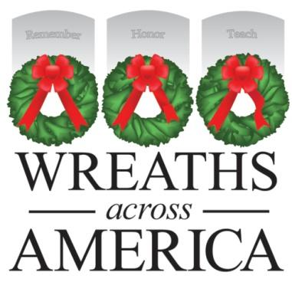

Company/Nonprofit Name
Address

Date

Dear [direct contact you have]:

Morrill Worcester was just 12 years old when a trip to Washington, D.C. and Arlington National Cemetery impressed upon him a sense of gratitude for the service and sacrifice of veterans. Years later, as a successful business owner, Worcester found a way to honor those veterans by delivering a surplus of wreaths from his wreath making company in Maine to Arlington and laying them on veterans’ headstones. What began as a small endeavor grew tremendously, and in 2007, Worcester founded Wreaths Across America, a nonprofit organization, to continue and expand upon the annual Arlington Wreath Project fulfilling a mission to remember the fallen, honor those that served and their families, and teach the next generation about the value of freedom. Today, more than 1,600 locations participate in the Wreaths Across America mission and wreath-laying ceremonies take place in all 50 states, at sea, and abroad, including [Local Cemetery Location] in [Town].

Wreaths Across America invites you to Remember the fallen, Honor those that serve, and Teach the next generation about the value of freedom by becoming a local Fundraising Group during our 2019 Giving in July national campaign. With your support, you can help us honor our nation’s veterans and all active duty military personnel while doing good twice. Through the sale of $15 wreath sponsorships, your organization can earn $5 back to support your own community programs. As a result of this fundraising program, Wreaths Across America has given back more than $10 million nationally to other like-minded nonprofits and civic group partners over the last 11 years.
Through the Giving in July campaign, Wreaths Across America invites Americans to remember our veterans and military families not only during the winter holidays, but year-round. Too often we recognize deployed servicemen and women only as the holidays approach and their absence from home is felt most strongly. Giving in July reminds us that veterans and our current military serve and protect us 365 days a year. Like Christmas in July, considering our own charity during the summer months provides us the opportunity to encourage others to get involved early with the WAA mission – Remember, Honor, Teach - and support our nation’s veterans in the communities they live throughout the year.

On behalf of the volunteers and military families looking to honor all the veterans in [LOCATION], and the Wreaths Across America extended family, I thank you for your consideration of becoming a fundraising group for this patriotic cause. I’ll be in touch to determine your interest in supporting the mission to Remember, Honor, Teach.

Respectfully,

Name
WAA Volunteer Title/Participating Cemetery Location
Contact info

DON’T FORGET TO INCLUDE YOUR GROUP OR LOCATION ID TO GET CREDIT

***INFO ONLY For Location Coordinators and Fundraising Group Leaders***

- Donation options for businesses would be to set up a Fundraising Group page through WreathsAcrossAmerica.org and promote that link themselves to raise funds, or to contribute a lump sum donation directly to the program or through a Group.
- For nonprofits, the set-up is the same and they get the $5 back for their own programs.
- If a business agrees to do a match during the month of July, they could say up to a specific amount and that would ensure their donation is the total of what they are willing to spend - however, often times if the public believes their donation will be amplified in some way, it can help spur giving.
- In exchange for a business or nonprofits support, you can offer to do a press release about their involvement and share with local media. WAA will provide a template press release you can customize and share locally.
- Depending on the size of the sponsorship, you can also offer to do posts on your location social media pages highlighting the business/nonprofit for their support and/or add the business name and logo to your event program or promotions. This is entirely up to you and what visibility you have to offer.

